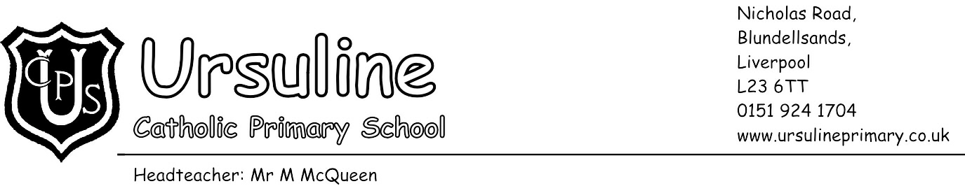

Friday 25th March 2018

Dear Parent/Carer,

You may be aware that the rules around data protection are changing today. The 'General Data Protection Regulation' (GDPR) will change how we can use your personal data and keep it safe, and will also strengthen your rights over your own data.

The regulations are designed to ensure sensitive or private information about yourselves and your children stays safe. Whilst it is similar to the current Data Protection Act in many ways, there are a few differences, so we need to make a few changes at the school in order to ensure we remain compliant. As a result of this we have updated our privacy notices. You can find copies of these on our school website at http://www.ursulineprimary.co.uk/information/key-information/school-policies.

If you have any questions about how the GDPR affects you, or how our school is preparing, you can contact us via the school office.

Yours faithfully,

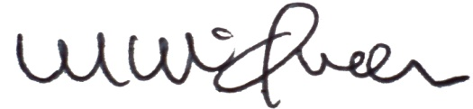

Mr M McQueen
Head teacher

